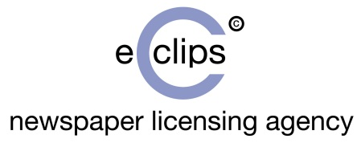

NLA eClips Login Issues

If you are having trouble logging in to view your eClips content, please try the following:

- NLA login screen

Please check that it is the NLA login screen that you are trying to access and not the login screen of your content provider.

NLA login screen:
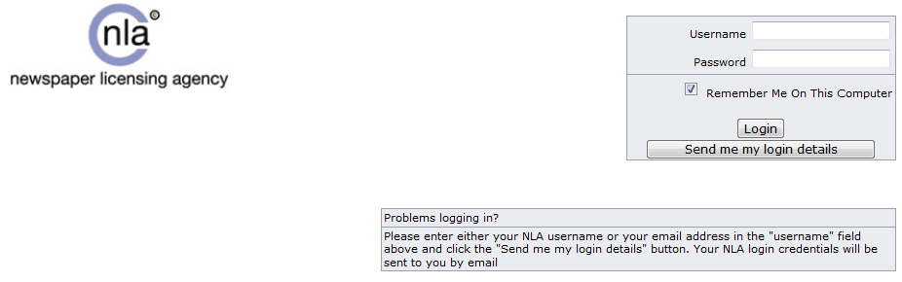

If you are trying to login to your content provider’s portal, then you will need to contact them directly.

- Incorrect username and password

If you are presented with an error message stating that your username/password is incorrect, then please ensure that your spelling is correct before clearing your NLA cookies and trying to login again.

To clear your NLA cookies, please visit http://www.nla-eclips.com/clients/clearcookie.asp and select ‘Clear Cookies’. You will need to close your internet browser before trying to login again.

- Login screen refresh

If your login screen is refreshing back to a blank login screen then you will need to enable your internet browser to ‘Accept’ 3rd party cookies. Cookie settings are usually found on the top right-hand side of your internet browser under: tools/Internet options/Privacy/Advanced.

- Organisation access module prohibited

If you are presented with an error message that says ‘organisation access module prohibited’ then please email clientservices@nla.uk as they will be able to rectify this for you.

- Other

If these solutions do not work, then please email clientservices@nla.co.uk with a screenshot of the error message and confirm the username/password you are trying to login with.

